Ring Torus
# Source: AI Source: Provided by: [Data Path: Persons Table -> ID Column: 1, Name_En Column: Motasem Essam] -> From: [ChatGPT] on [7/20/2026]
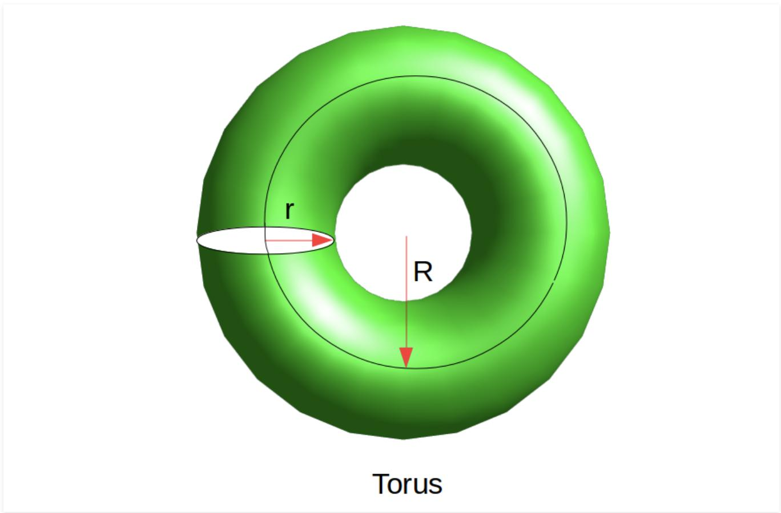
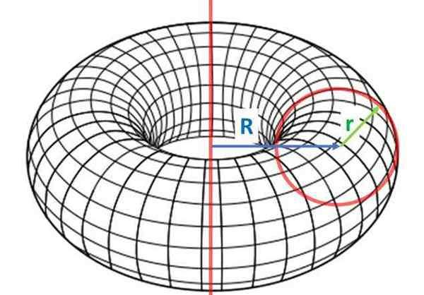
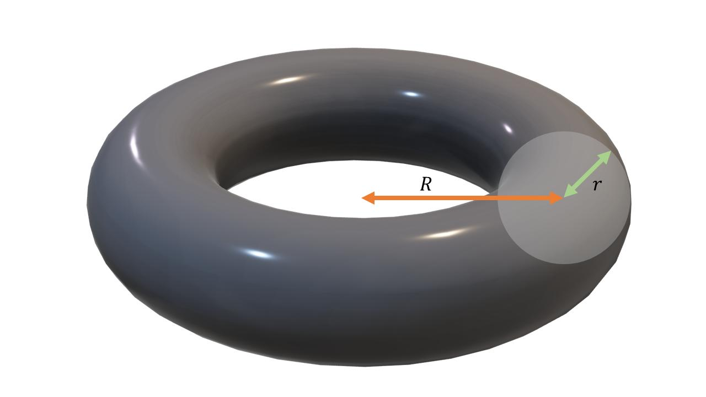
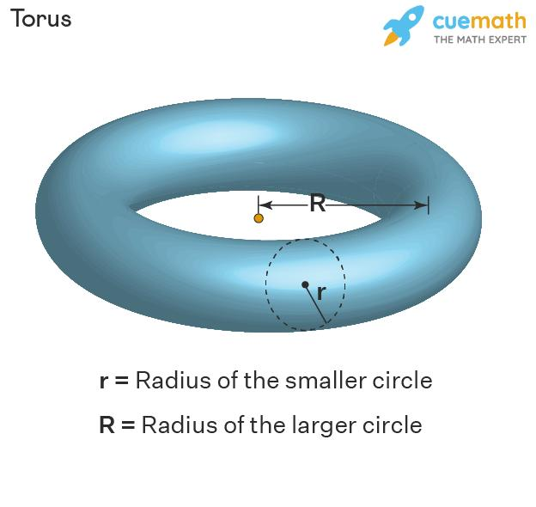
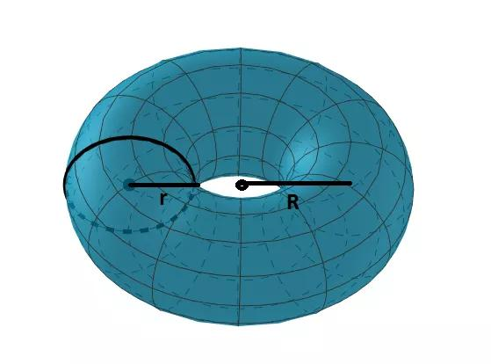
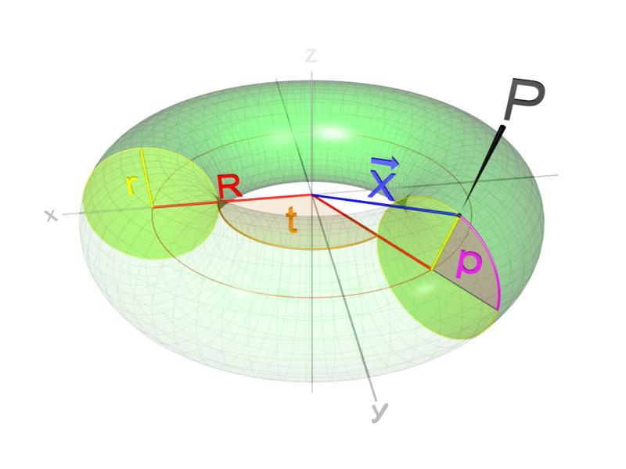

Definition
# Source: AI Source: Provided by: [Data Path: Persons Table -> ID Column: 1, Name_En Column: Motasem Essam] -> From: [ChatGPT] on [7/20/2026]
A Ring Torus is a type of toroidal surface formed by rotating a circle around an axis in the same plane as the circle, where the axis lies outside the circle.
It produces the familiar doughnut-shaped surface.
The defining condition is
$$\boxed{R>r}$$
where:
- $R$= major radius, the distance from the axis of rotation to the center of the generating circle.
- $r$= minor radius, the radius of the generating circle.
Because $R>r$, the generating circle does not touch or cross the axis of rotation.

Purpose
# Source: AI Source: Provided by: [Data Path: Persons Table -> ID Column: 1, Name_En Column: Motasem Essam] -> From: [ChatGPT] on [7/20/2026]
A ring torus is used to:
- Study toroidal surfaces.
- Model doughnut-shaped geometric objects.
- Calculate surface area and enclosed volume.
- Study surfaces of revolution.
- Provide a fundamental example of a closed curved surface.
- Model objects in engineering, physics, architecture, and computer graphics.

Fundamental Elements
# Source: AI Source: Provided by: [Data Path: Persons Table -> ID Column: 1, Name_En Column: Motasem Essam] -> From: [ChatGPT] on [7/20/2026]
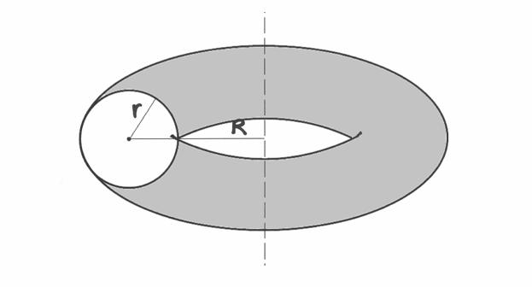

1. Major Radius $R$
# Source: AI Source: Provided by: [Data Path: Persons Table -> ID Column: 1, Name_En Column: Motasem Essam] -> From: [ChatGPT] on [7/20/2026]
The major radius is the distance from the axis of rotation to the center of the generating circle.
$$\boxed{R=\text{distance from rotation axis to generating-circle center}}$$

2. Minor Radius $r$
# Source: AI Source: Provided by: [Data Path: Persons Table -> ID Column: 1, Name_En Column: Motasem Essam] -> From: [ChatGPT] on [7/20/2026]
The minor radius is the radius of the generating circle.
$$\boxed{r=\text{radius of generating circle}}$$

3. Axis of Rotation
# Source: AI Source: Provided by: [Data Path: Persons Table -> ID Column: 1, Name_En Column: Motasem Essam] -> From: [ChatGPT] on [7/20/2026]
The torus is generated by rotating the circle around an axis in the same plane as the circle.
For a ring torus, this axis does not intersect the generating circle.

4. Generating Circle
# Source: AI Source: Provided by: [Data Path: Persons Table -> ID Column: 1, Name_En Column: Motasem Essam] -> From: [ChatGPT] on [7/20/2026]
The generating circle is the circle that is rotated to create the toroidal surface.
5. Central Circle
The circle traced by the center of the generating circle during rotation is called the central circle or major circle.
Its radius is
$$R.$$

Formation of a Ring Torus
# Source: AI Source: Provided by: [Data Path: Persons Table -> ID Column: 1, Name_En Column: Motasem Essam] -> From: [ChatGPT] on [7/20/2026]
A ring torus can be constructed in the following way:
- Draw a circle of radius $r$.
- Place its center a distance $R$from an external axis.
- Rotate the circle through ${360}^{∘}$.
- The circle sweeps out the ring toroidal surface.
Conceptually:
$$\boxed{\text{Circle}\underset{→}{\text{rotation around external axis}}\text{Ring Torus}}$$
Because
$$R>r,$$
the circle remains completely separated from the axis during the rotation.

Mathematical Representation
# Source: AI Source: Provided by: [Data Path: Persons Table -> ID Column: 1, Name_En Column: Motasem Essam] -> From: [ChatGPT] on [7/20/2026]
For a ring torus centered at the origin with its axis along the $z$-axis, the standard Cartesian equation is
$$\boxed{{\left(\sqrt{x^{2}+y^{2}}-R\right)}^{2}+z^{2}=r^{2}}$$
with
$$\boxed{R>r>0}.$$
An equivalent polynomial form is
$$\boxed{{\left(x^{2}+y^{2}+z^{2}+R^{2}-r^{2}\right)}^{2}=4R^{2}\left(x^{2}+y^{2}\right)}.$$

Parametric Representation
# Source: AI Source: Provided by: [Data Path: Persons Table -> ID Column: 1, Name_En Column: Motasem Essam] -> From: [ChatGPT] on [7/20/2026]
A standard parameterization of a ring torus is
$$\boxed{x=\left(R+r\cos{v}\right)\cos{u}} \\ \boxed{y=\left(R+r\cos{v}\right)\sin{u}} \\ \boxed{z=r\sin{v}}$$
where
$$0≤u<2π$$
and
$$0≤v<2π.$$
Here:
- $u$controls the rotation around the main axis.
- $v$moves around the generating circle.
The condition
$$R>r$$
ensures that the torus is a ring torus.

Surface Area
# Source: AI Source: Provided by: [Data Path: Persons Table -> ID Column: 1, Name_En Column: Motasem Essam] -> From: [ChatGPT] on [7/20/2026]
The surface area of a ring torus is
$$\boxed{A=4π^{2}Rr}.$$
This result follows from Pappus's centroid theorem.
The generating circle has:
$$\text{Circumference}=2πr$$
and its center travels a distance
$$2πR$$
during one complete revolution.
Therefore,
$$A=\left(2πr\right)\left(2πR\right)$$
giving
$$\boxed{A=4π^{2}Rr}.$$

Enclosed Volume
# Source: AI Source: Provided by: [Data Path: Persons Table -> ID Column: 1, Name_En Column: Motasem Essam] -> From: [ChatGPT] on [7/20/2026]
The solid enclosed by a ring torus has volume
$$\boxed{V=2π^{2}Rr^{2}}.$$
This can also be obtained from Pappus's centroid theorem.
The generating circle has area
$$πr^{2}$$
and its center travels
$$2πR.$$
Therefore,
$$V=\left(πr^{2}\right)\left(2πR\right)$$
and hence
$$\boxed{V=2π^{2}Rr^{2}}.$$

Example 1 – Surface Area
# Source: AI Source: Provided by: [Data Path: Persons Table -> ID Column: 1, Name_En Column: Motasem Essam] -> From: [ChatGPT] on [7/20/2026]
Suppose
$$R=10\text{ cm}$$
and
$$r=3\text{ cm}.$$
Since
$$10>3,$$
the surface is a ring torus.
Using
$$A=4π^{2}Rr,$$
we obtain
$$A=4π^{2}\left(10\right)\left(3\right) \\ \boxed{A=120π^{2}{\text{ cm}}^{2}}.$$
Approximately,
$$\boxed{A≈1184.35{\text{ cm}}^{2}}.$$

Example 2 – Enclosed Volume
# Source: AI Source: Provided by: [Data Path: Persons Table -> ID Column: 1, Name_En Column: Motasem Essam] -> From: [ChatGPT] on [7/20/2026]
Using
$$R=10\text{ cm}$$
and
$$r=3\text{ cm},$$
the enclosed volume is
$$V=2π^{2}Rr^{2}.$$
Therefore,
$$V=2π^{2}\left(10\right)\left(3^{2}\right) \\ V=180π^{2}$$
and
$$\boxed{V=180π^{2}{\text{ cm}}^{3}}.$$
Approximately,
$$\boxed{V≈1776.53{\text{ cm}}^{3}}.$$

Example 3 – Identifying a Ring Torus
# Source: AI Source: Provided by: [Data Path: Persons Table -> ID Column: 1, Name_En Column: Motasem Essam] -> From: [ChatGPT] on [7/20/2026]
Suppose
$$R=8\text{ cm}$$
and
$$r=5\text{ cm}.$$
Since
$$R>r,$$
we have
$$8>5.$$
Therefore, the torus is a
$$\boxed{\text{Ring Torus}}.$$
If instead
$$R=r,$$
the torus would be a Horn Torus.
If
$$R<r,$$
it would be a Spindle Torus.

Main Properties
# Source: AI Source: Provided by: [Data Path: Persons Table -> ID Column: 1, Name_En Column: Motasem Essam] -> From: [ChatGPT] on [7/20/2026]
A ring torus has the following properties:
- It is a toroidal surface.
- It is generated by rotating a circle.
- The generating circle's center is outside the rotation axis.
- Its defining condition is
$$\boxed{R>r}.$$
- It is a closed surface.
- It has no boundary.
- It has no vertices.
- It has no edges in the ordinary polyhedral sense.
- It has a central hole.
- It has rotational symmetry about its axis.
- A standard ring torus has circular cross-sections perpendicular to the generating-circle construction.
- Its surface area is
$$\boxed{4π^{2}Rr}.$$
- Its enclosed volume is
$$\boxed{2π^{2}Rr^{2}}.$$

Topological Structure
# Source: AI Source: Provided by: [Data Path: Persons Table -> ID Column: 1, Name_En Column: Motasem Essam] -> From: [ChatGPT] on [7/20/2026]
A ring torus has the topology of a mathematical torus.
It has:
- One continuous outer surface.
- One central hole.
- No boundary.
- One connected surface.
It can be visualized as a surface with a hole passing completely through its center.

Ring Torus vs Other Types of Toroidal Surfaces
# Source: AI Source: Provided by: [Data Path: Persons Table -> ID Column: 1, Name_En Column: Motasem Essam] -> From: [ChatGPT] on [7/20/2026]
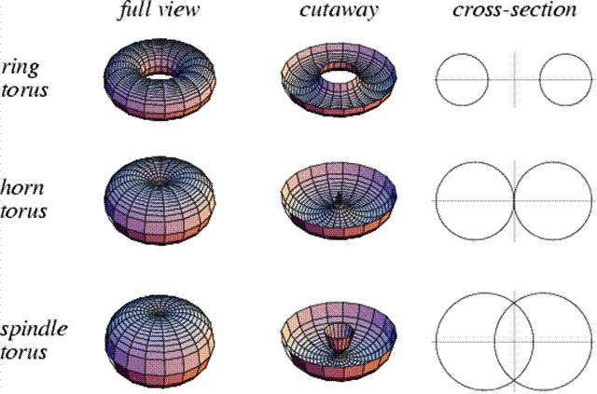
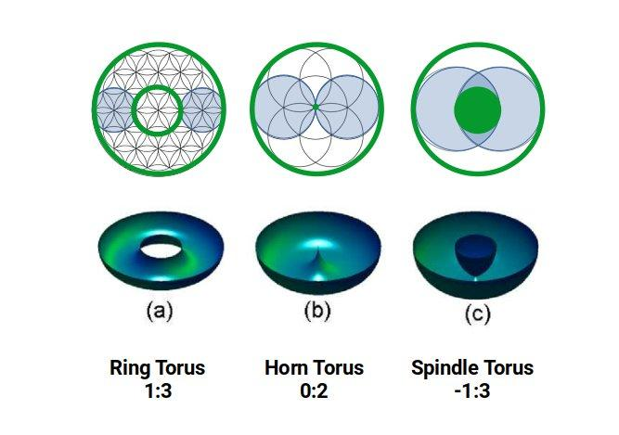
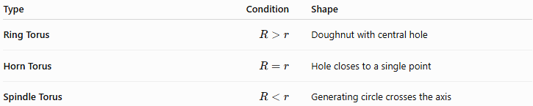
Type | Condition | Shape
Ring Torus | $$R>r$$ | Doughnut with central hole
Horn Torus | $$R=r$$ | Hole closes to a single point
Spindle Torus | $$R<r$$ | Generating circle crosses the axis
Therefore:
$$\boxed{R>r⇒\text{Ring Torus}} \\ \boxed{R=r⇒\text{Horn Torus}} \\ \boxed{R<r⇒\text{Spindle Torus}}$$

Ring Torus vs Sphere
# Source: AI Source: Provided by: [Data Path: Persons Table -> ID Column: 1, Name_En Column: Motasem Essam] -> From: [ChatGPT] on [7/20/2026]
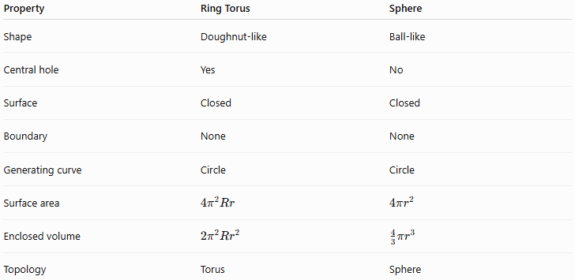
Property | Ring Torus | Sphere
Shape | Doughnut-like | Ball-like
Central hole | Yes | No
Surface | Closed | Closed
Boundary | None | None
Generating curve | Circle | Circle
Surface area | $$4π^{2}Rr$$ | $$4πr^{2}$$
Enclosed volume | $$2π^{2}Rr^{2}$$ | $$\frac{4}{3}πr^{3}$$
Topology | Torus | Sphere
Although both can be generated using circles, their resulting surfaces are fundamentally different.

Ring Torus vs Circular Cylindrical Surface
# Source: AI Source: Provided by: [Data Path: Persons Table -> ID Column: 1, Name_En Column: Motasem Essam] -> From: [ChatGPT] on [7/20/2026]
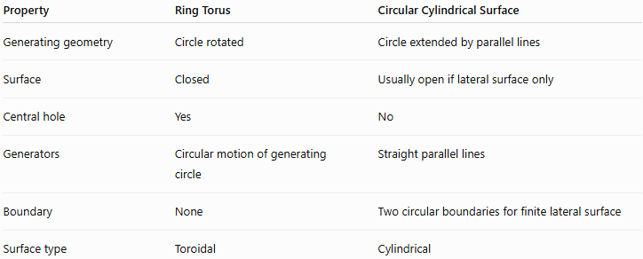
Property | Ring Torus | Circular Cylindrical Surface
Generating geometry | Circle rotated | Circle extended by parallel lines
Surface | Closed | Usually open if lateral surface only
Central hole | Yes | No
Generators | Circular motion of generating circle | Straight parallel lines
Boundary | None | Two circular boundaries for finite lateral surface
Surface type | Toroidal | Cylindrical

Real-World Applications
# Source: AI Source: Provided by: [Data Path: Persons Table -> ID Column: 1, Name_En Column: Motasem Essam] -> From: [ChatGPT] on [7/20/2026]
Ring-torus shapes are found or approximated in:
- O-rings
- Doughnut-shaped components
- Toroidal transformers
- Toroidal magnetic cores
- Seals and gaskets
- Tubular mechanical components
- Buoyancy devices
- Some architectural structures
- Computer graphics and 3D modeling
- Fluid and plasma simulations

Advantages
# Source: AI Source: Provided by: [Data Path: Persons Table -> ID Column: 1, Name_En Column: Motasem Essam] -> From: [ChatGPT] on [7/20/2026]
- Highly symmetric.
- Closed surface with no boundary.
- Simple parametric representation.
- Exact formulas for surface area and volume.
- Useful for modeling circular toroidal structures.
- Easy to generate computationally.

Limitations
# Source: AI Source: Provided by: [Data Path: Persons Table -> ID Column: 1, Name_En Column: Motasem Essam] -> From: [ChatGPT] on [7/20/2026]
- Restricted to the ring-torus condition
$$R>r.$$
- Does not represent horn or spindle tori.
- The formulas assume a standard circular torus.
- More complicated toroidal surfaces may require calculus or parametric methods.

Key Points
# Source: AI Source: Provided by: [Data Path: Persons Table -> ID Column: 1, Name_En Column: Motasem Essam] -> From: [ChatGPT] on [7/20/2026]
- A Ring Torus is the standard doughnut-shaped toroidal surface.
- It is created by rotating a circle around an external coplanar axis.
- Its defining condition is
$$\boxed{R>r}.$$
- $R$is the major radius.
- $r$is the minor radius.
- Its Cartesian equation is
$$\boxed{{\left(\sqrt{x^{2}+y^{2}}-R\right)}^{2}+z^{2}=r^{2}}.$$
- Its surface area is
$$\boxed{A=4π^{2}Rr}.$$
- Its enclosed volume is
$$\boxed{V=2π^{2}Rr^{2}}.$$
- It is a closed curved surface.
- It has a central hole.
- It is one of the three standard circular torus types: ring, horn, and spindle.

Conclusion
# Source: AI Source: Provided by: [Data Path: Persons Table -> ID Column: 1, Name_En Column: Motasem Essam] -> From: [ChatGPT] on [7/20/2026]
A Ring Torus is the standard form of a toroidal surface, produced by rotating a circle around an axis that lies outside the circle but in the same plane. Its defining geometric condition is
$$\boxed{R>r}.$$
Its major radius $R$determines the distance from the rotation axis to the center of the generating circle, while its minor radius $r$determines the thickness of the torus.
The two principal formulas are:
$$\boxed{A=4π^{2}Rr}$$
and
$$\boxed{V=2π^{2}Rr^{2}}.$$
For your knowledge base, the recommended classification is:
Surface
└── Curved Surface
└── Toroidal Surface
├── Ring Torus
├── Horn Torus
└── Spindle Torus
The Ring Torus should therefore be treated as a specific type of Toroidal Surface, characterized by $R>r$.

